SOFTWARE REQUIREMENTS SPECIFICATION

For

EMERGENCE: An Intelligent Classroom Learning System

March 2026

Prepared by

Specialization | SAP ID | Name
AIML | 500122588 | MOHIT KUMAR YADAV
AI Cluster
School Of Computer Science
UNIVERSITY OF PETROLEUM & ENERGY STUDIES,
DEHRADUN- 248007. Uttarakhand

Dr. Anil Kumar Dr. Anil Kumar
Project Mentor Cluster Head : AI
Cluster Head: AI SoCS, UPES Dehradun
SoCS, UPES Dehradun

Table of Contents
Topic |  | Page No
Table of Content |  | 1
Revision History |  | 2
1 | Introduction | 3-4
 | 1.1 Purpose of the Project
 | 1.2 Target Beneficiary
 | 1.3 Project Scope
 | 1.4 References
2 | Project Description | 5-13
 | 2.1 Reference Algorithm
 | 2.2 Data/ Data structure
 | 2.3 SWOT Analysis
 | 2.4 Project Features
 | 2.5 User Classes and Characteristics
 | 2.6 Design and Implementation Constraints
 | 2.7 Design diagrams
 | 2.8 Assumption and Dependencies
3 | System Requirements | 14-16
 | 3.1 User Interface
 | 3.2 Software Interface
 | 3.3 Database Interface
 | 3.4 Protocols
4 | Non-functional Requirements | 16-17
 | 4.1 Performance requirements
 | 4.2 Security requirements
 | 4.3 Software Quality Attributes
5 | Other Requirements | 17
Appendix A: Glossary |  | 18
Appendix B: Analysis Model |  | 18
Appendix C: Issues List |  | 18

Revision History

Date | Change | Reason for Changes | Mentor Signature
March 2026 | Initial SRS Draft | Mid-semester report submission

1. INTRODUCTION

1.1 Purpose of the Project

Problem Statement:
Traditional classroom instruction follows a one-size-fits-all model, where a single teaching strategy is applied uniformly to all students regardless of their individual engagement levels, learning pace, or cognitive readiness. Teachers in large classrooms (30-60 students) cannot simultaneously monitor every student's attention, posture, and participation in real time. Research shows that up to 40% of students in a typical lecture may be disengaged at any given moment, yet instructors lack objective, real-time data to identify and address this. As a result, disengaged students fall behind, highly engaged students are under-challenged, and the overall learning outcome suffers.

Motivation:
EMERGENCE addresses this gap by combining Computer Vision (for real-time perception of student behavior), Unsupervised Machine Learning (for reasoning and clustering students by engagement patterns), and Generative AI (for producing personalized learning content). The system transforms passive classroom observation into active, data-driven pedagogical adaptation — enabling teachers to deliver differentiated instruction without manual effort.

Justification:
Unlike existing classroom monitoring tools that simply count attendance or flag phone usage, EMERGENCE provides a complete perception-reasoning-generation loop: it observes engagement signals (gaze, posture, motion), reasons over them (clustering students into profiles), and generates adaptive responses (personalized learning modules and micro-tests). This three-layer architecture is novel in its integration of real-time behavioral analytics with generative content creation for educational settings.

1.2 Target Beneficiary
- Teachers / Instructors — Receive real-time engagement dashboards showing which students need attention, enabling targeted intervention during lectures.
- Students — Receive personalized learning modules adapted to their engagement level (simplified content for struggling students, advanced challenges for highly engaged ones).
- Educational Institutions — Gain data-driven insights into classroom dynamics, teaching effectiveness, and student behavior patterns over time.
- Education Researchers — Access structured engagement datasets for studying attention patterns, classroom behavior, and adaptive learning outcomes.

1.3 Project Scope:

Application Area: EMERGENCE is an Intelligent Classroom Learning System
for higher education and school environments. It processes classroom video feeds (live webcam or recorded) to detect and track students, extract behavioral signals, compute engagement metrics, cluster students into learning profiles, and generate personalized educational content.
Key Deliverables:
- A Vision Pipeline that processes video input to produce frame-by-frame engagement logs (
engagement_log.csv)
- A Reasoning Engine that clusters students into engagement profiles using K-Means (
student_profiles.csv)
- A Generative Module that produces personalized learning content and micro-tests via Google Gemini LLM
- A Streamlit Dashboard for real-time visualization of engagement analytics
- A CLI interface (
main.py) for running the full pipeline end-to-end
Objectives:
- Detect and track individual students using YOLO object detection
- Extract gaze direction, posture alignment, and motion energy per student per frame
- Compute a fused engagement score using weighted fusion: 0.6×Gaze + 0.25×Posture + 0.15×Motion
- Cluster students into 3 profiles: "Needs Support", "Active", "Highly Engaged"
- Generate difficulty-adapted micro-tests and personalized learning modules
Benefits:
- Non-invasive monitoring (no wearables required, camera-only)
- Real-time processing capability
- Automatic content adaptation without teacher intervention
- Scalable to any classroom size

1.4 References
- Redmon, J. et al. — “You Only Look Once: Unified, Real-Time Object Detection,” CVPR 2016
- Ultralytics YOLOv11 Documentation — https://docs.ultralytics.com/
- MediaPipe Pose Estimation — https://ai.google.dev/edge/mediapipe
- Google Gemini API Documentation — https://ai.google.dev/gemini-api/docs
- Scikit-learn K-Means Clustering — https://scikit-learn.org/stable/modules/clustering.html
- OpenCV Optical Flow (Farneback) — https://docs.opencv.org/
- Streamlit Documentation — https://docs.streamlit.io/
- SCB (Student Classroom Behavior) Dataset — https://huggingface.co/datasets/wintonYF/SCB-Dataset
- IEEE 830-1998 — IEEE Recommended Practice for SRS
- Whitehill, J. et al. — “The Faces of Engagement: Automatic Recognition of Student Engagement from Facial Expressions,” IEEE Trans. On Affective Computing, 2014

2. PROJECT DESCRIPTION

2.1 Reference Algorithm
Primary Algorithms:
1. YOLOv11 (You Only Look Once) — Object Detection & Tracking
- Used for real-time student detection in video frames
- Provides bounding boxes and persistent tracking IDs via built-in tracker
- Data Structure: List of detection dictionaries {bbox, class_id, class_name, conf, track_id}
2. YOLO-Pose — Keypoint Estimation
- Extracts 17 body keypoints per detected person (nose, eyes, ears, shoulders, etc.)
- Used to compute gaze score (head yaw from ear-nose symmetry) and posture score (shoulder slope alignment)
- Data Structure: Tensor of shape [N, 17, 3] (x, y, confidence per keypoint)
3. Farneback Dense Optical Flow — Motion Analysis
- Computes pixel-level motion vectors between consecutive video frames
- Calculates average motion magnitude as normalized motion energy score (0.0–1.0)
- Data Structure: Flow field of shape [H, W, 2] (dx, dy per pixel)
4. K-Means Clustering — Unsupervised Student Profiling
- Groups students into 3 clusters based on average engagement and gaze scores
- Cluster centroids determine the label mapping: Needs Support → Active → Highly Engaged
- Data Structure: Feature matrix X = [engagement_score, gaze_score] per student
5. Google Gemini 2.0 Flash — Generative Content
- Generates personalized learning modules and MCQ micro-tests
- Prompts are tailored per cluster (difficulty: easy-recall / medium / hard-application)
- Data Structure: JSON (micro-tests), Markdown (learning modules)

Engagement Score Fusion Formula:
Engagement Score = 0.6 × Gaze Score + 0.25 × Posture Score + 0.15 × Motion Score

2.2 Characteristic of Data
Primary Data Source:
- Classroom Video — Recorded MP4 file (
iNPUT.mp4, 96 MB) of a real classroom session with ~10-12 visible students
- Live Webcam Feed — Real-time input via system camera (DirectShow backend on Windows)
Secondary Data Source:
- SCB (Student Classroom Behavior) Dataset — From HuggingFace (wintonYF/SCB-Dataset) containing labeled classroom images with 8 behavior classes (hand_raising, reading, writing, discussing, turning_head, bowing_head, sleeping, standing)
Data Processing Pipeline:
- Extraction: Video frames extracted at native FPS using OpenCV VideoCapture
- Detection: Each frame processed through YOLO to detect student bounding boxes
- Feature Extraction: Per-student crop → YOLO-Pose for keypoints → gaze/posture scores; Optical flow for motion score
- Fusion: Weighted combination of gaze, posture, motion into engagement score
- Aggregation: Frame-level data grouped by student_id, averaged over all frames
- Clustering: K-Means applied on aggregated student features

Output Data Characteristics:
Dataset | Format | Rows | Columns | Description
engagement_log.csv | CSV | 215 | 8 | Frame-by-frame per-student engagement data
student_profiles.csv | CSV | 11 | 7 | Aggregated student profiles with cluster labels
module_*.md | Markdown | Varies | N/A | Per-student personalized learning modules
Statistical Methods:
- Mean aggregation of per-frame metrics per student
- K-Means (unsupervised) for student clustering with n_clusters=3
- Score normalization: Motion score capped at 1.0 (heuristic: avg_motion/5.0), gaze and posture derived from geometric ratios of keypoint positions

2.3 SWOT Analysis
 | Helpful | Harmful
Internal | Strengths | Weaknesses
 | • Non-invasive (camera-only, no wearables) | • Requires clear camera angle of all students
 | • Real-time processing capability | • Free-tier API quota limits for Gemini LLM
 | • Complete 3-layer architecture (Vision→Reasoning→Generation) | • Gaze estimation is approximate (no dedicated eye tracker)
 | • Personalized content generation per student profile | • Currently uses generic YOLO (not classroom-specific)
 | • Open-source tech stack (YOLO, OpenCV, Scikit-learn) | • Single-camera limitation (no multi-angle fusion)
External | Opportunities | Threats
 | • Custom YOLO training on SCB dataset for behavior-specific classes | • Privacy concerns around classroom video surveillance
 | • Integration with LMS platforms (Moodle, Canvas) | • Changes in Gemini API pricing / availability
 | • Extension to online classrooms (webcam-based) | • Institutional resistance to AI-based monitoring
 | • Multi-modal fusion with audio analysis | • Varying lighting / occlusion in real classrooms

2.4 Project Features
Major Features:
- Real-time Student Detection & Tracking — YOLO identifies and tracks individual students across video frames with unique IDs
- Gaze & Posture Analysis — YOLO-Pose keypoints used to estimate head orientation (gaze) and shoulder alignment (posture)
- Motion Energy Computation — Dense optical flow measures student body movement over time
- Engagement Score Fusion — Weighted combination of gaze, posture, and motion into a single 0-1 engagement metric
- Student Clustering — K-Means groups students into "Needs Support", "Active", "Highly Engaged" profiles
- Adaptive Micro-Test Generation — Gemini creates difficulty-adapted MCQ questions based on student engagement level
- Personalized Learning Modules — Gemini generates customized learning content with different strategies per cluster
- Interactive Dashboard — Streamlit-based visualization of engagement trends, cluster distributions, and generated content

(see Diagrams section below)

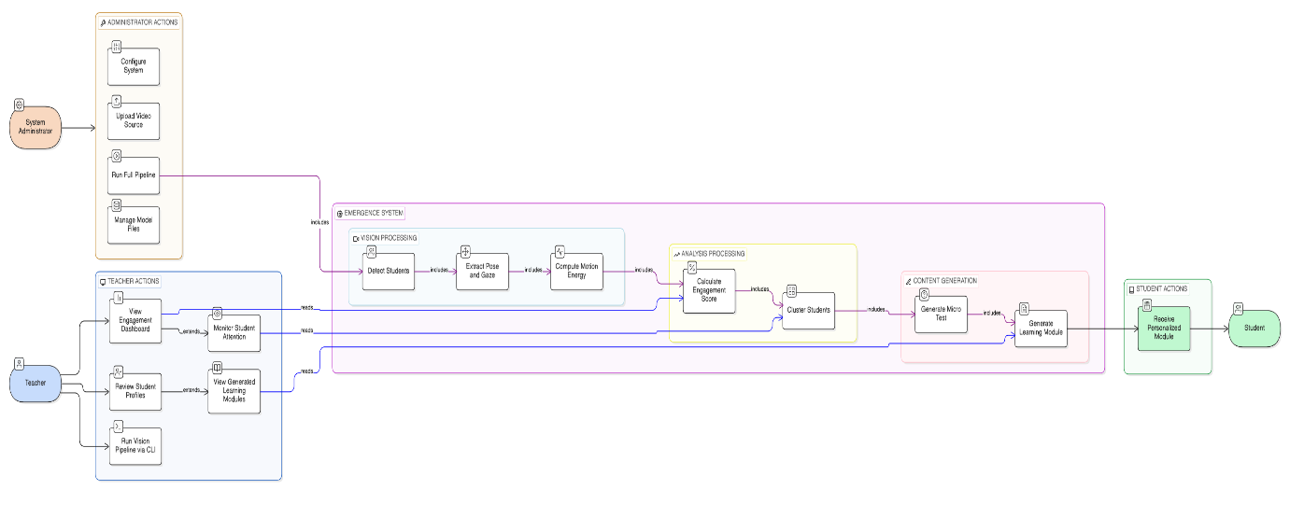

2.5 User Classes and Characteristics
User Class | Description | Technical Skill | Frequency of Use
Teacher / Instructor | Uses the dashboard to monitor real-time student engagement; reviews generated reports and learning modules | Low-Medium (basic web browser usage) | Daily during lectures
System Administrator | Installs, configures, and maintains the system; manages API keys, camera setup, and model files | High (Python, CLI, deployment) | Occasional setup & maintenance
Student | Passive user (observed by the system); receives personalized learning modules generated by the system | Low (receives output, no direct interaction) | Indirect — content delivered post-class
Education Researcher | Accesses engagement datasets for analysis and research on classroom behavior patterns | Medium-High (data analysis skills) | Periodic research use

2.6 Design and Implementation Constraints
Hardware Requirements:
- Processor: Minimum Intel i5 / AMD Ryzen 5 (GPU recommended for YOLO inference: NVIDIA GTX 1060+)
- RAM: Minimum 8 GB (16 GB recommended for concurrent vision + LLM processing)
- Storage: 500 MB for system + ~100 MB per video file + YOLO model weights (~40-45 MB each)
- Camera: Any USB webcam or IP camera; pre-recorded MP4 files also supported
Software Requirements:
- OS: Windows 10/11, Linux (Ubuntu 20.04+), macOS
- Python: 3.10+
- Key Libraries: ultralytics (YOLO), opencv-python, pandas, scikit-learn, google-generativeai, streamlit, plotly
- API: Google Gemini API key (free tier or paid)
Constraints:
- Gemini free-tier has rate limits (15 RPM, 1M tokens/min)
- YOLO inference speed depends on hardware (CPU: ~5-8 FPS, GPU: ~30+ FPS)
- Single-camera input only (no multi-view fusion in current version)
- English-language content generation only
- Internet required for Gemini API calls (vision & reasoning layers work offline)
Programming Standards:
- Python PEP 8 coding conventions
- Modular architecture with separate packages for vision, reasoning, and generation
- Configuration centralized in
src/config.py
- Environment variables for secrets (.env file for API keys)

2.7 Design Diagrams
- Use Case Diagram — Shows actors (Teacher, Student, System Admin) and their interactions

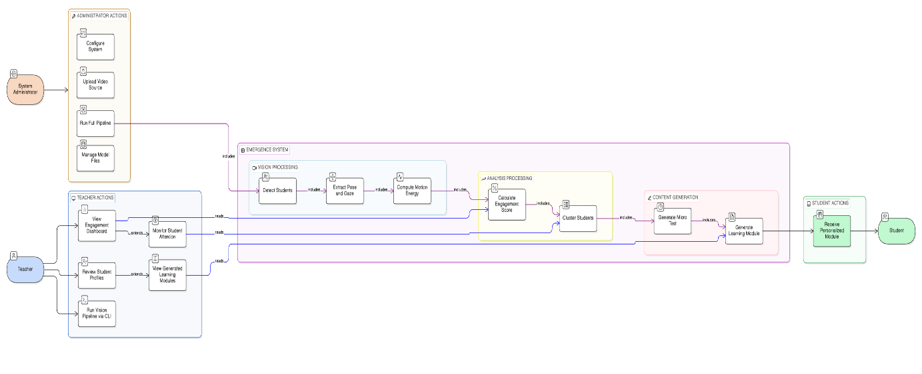

- Class Diagram — Shows all classes and their relationships

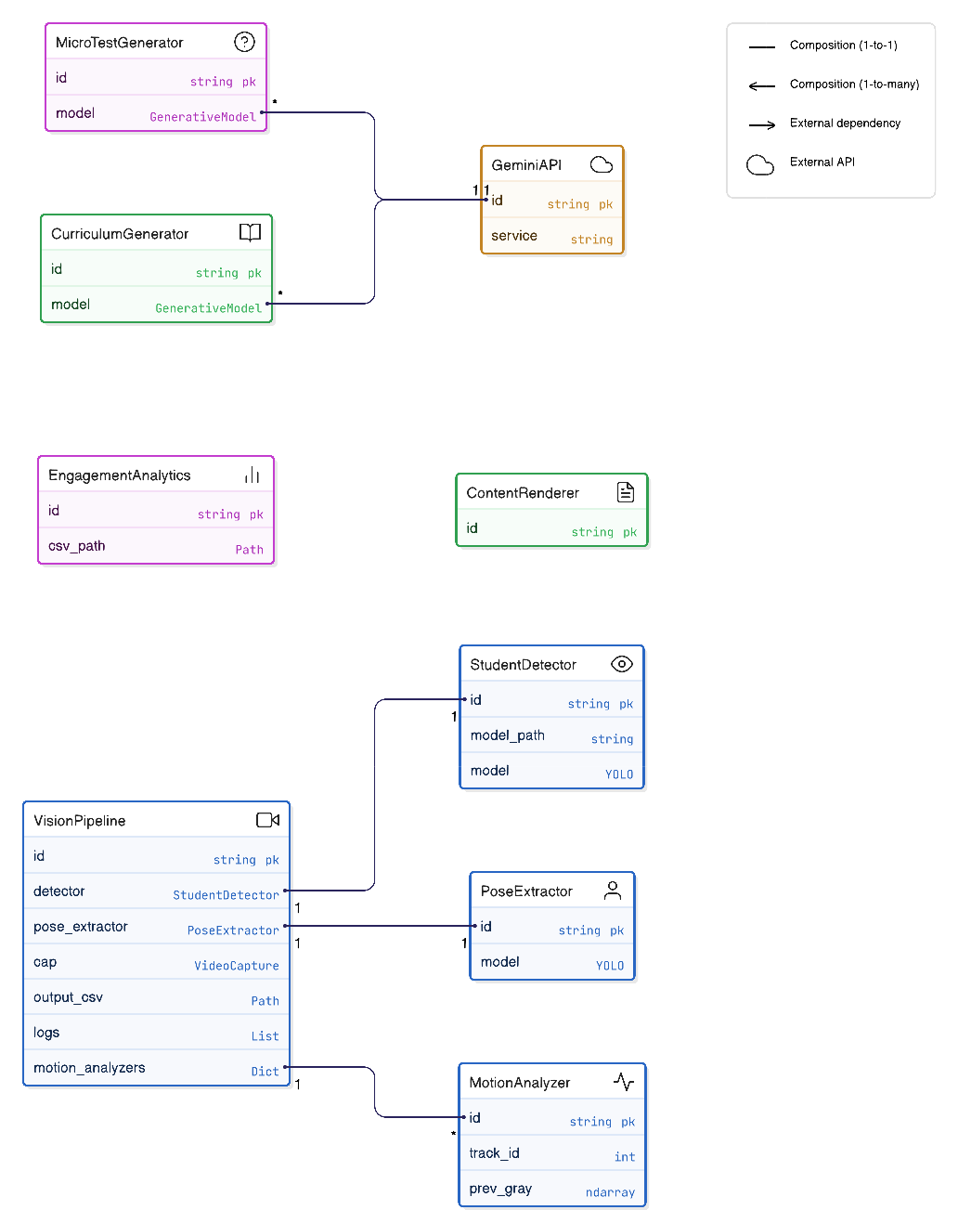

- Activity Diagram — Shows the full pipeline workflow

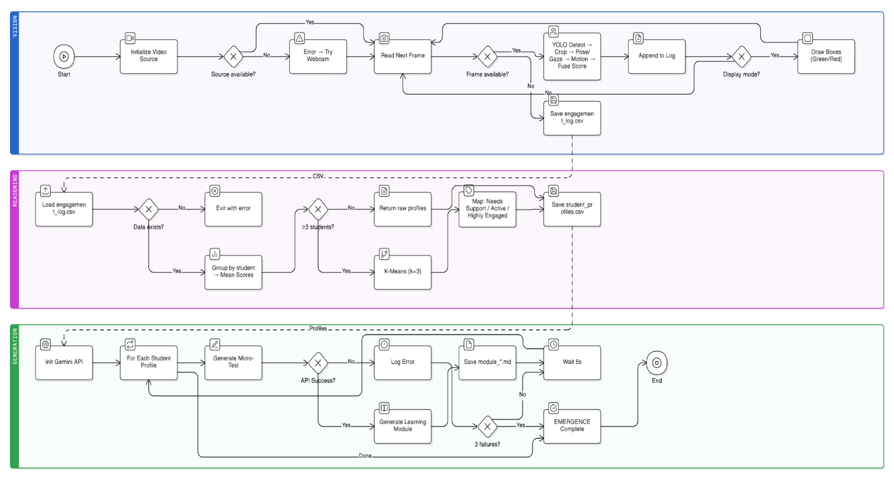

- Sequence Diagram — Shows object interactions for one pipeline run
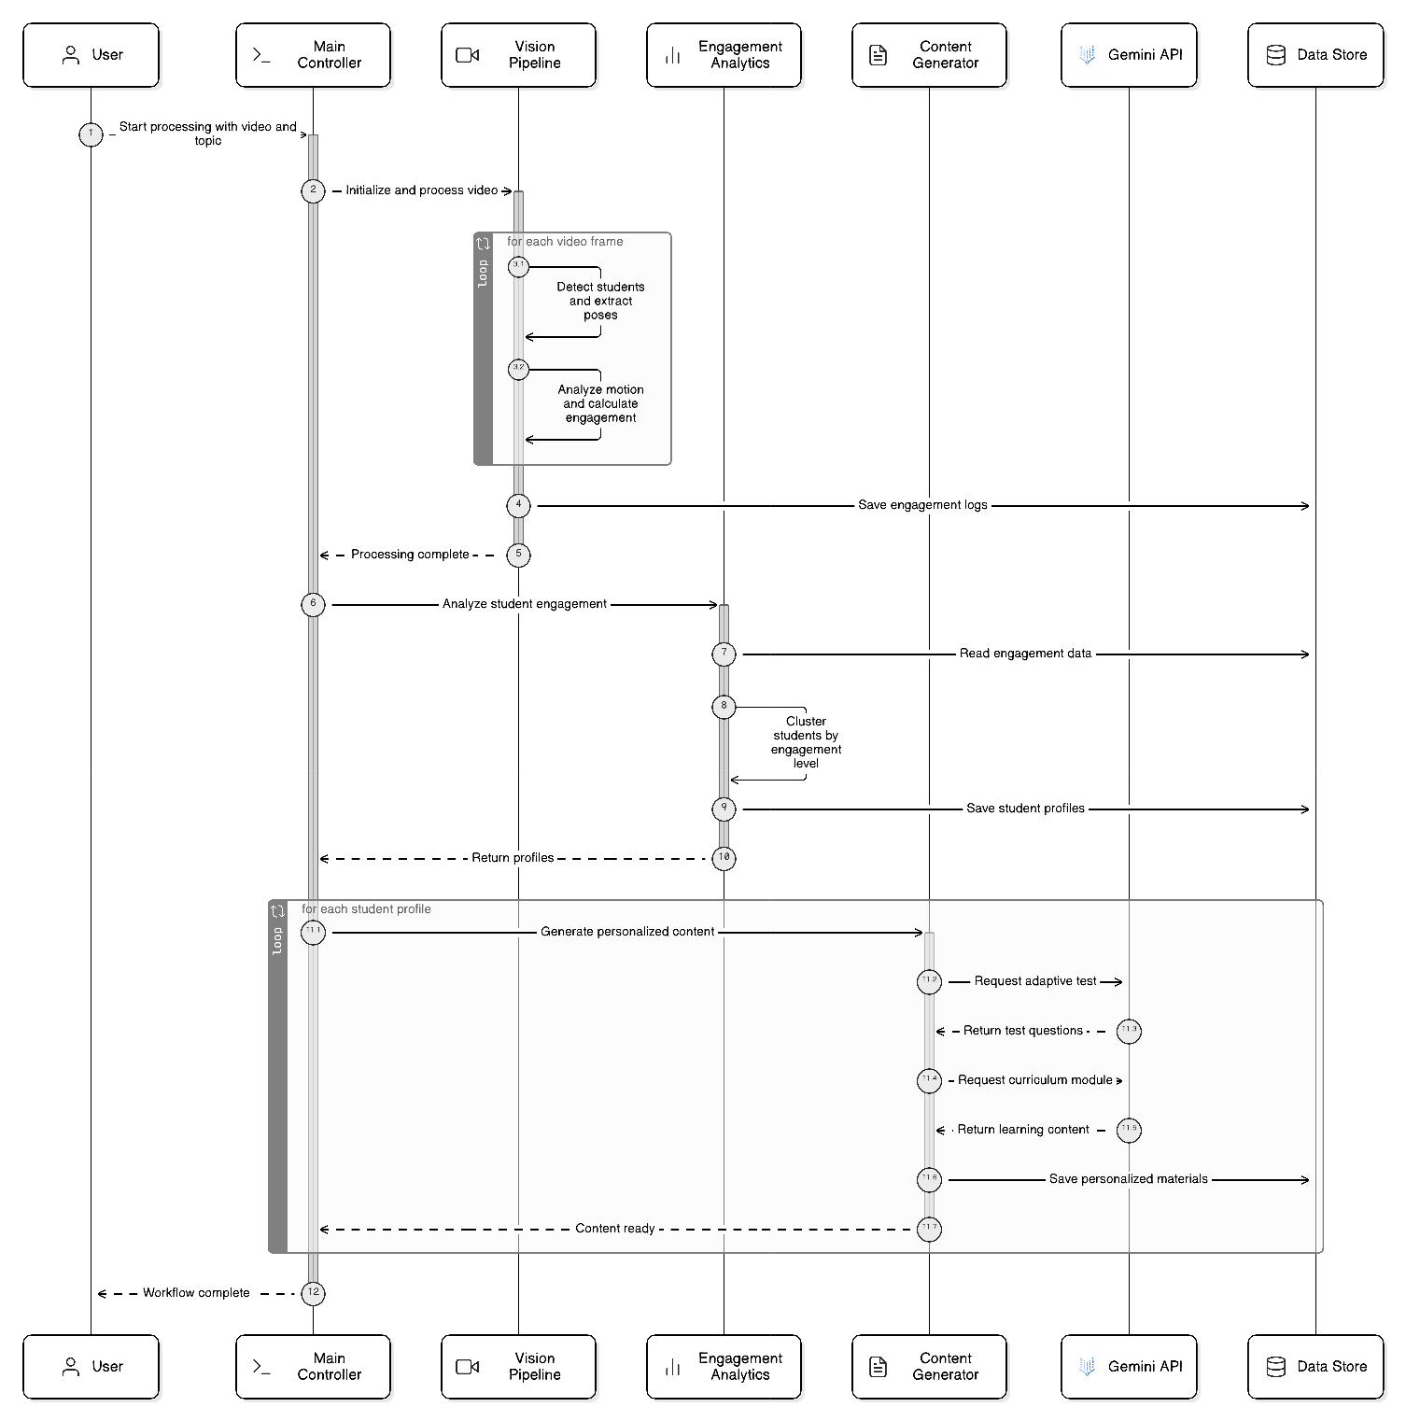

- Data Flow Diagram (Level 0 + Level 1) — Shows data flow through the system
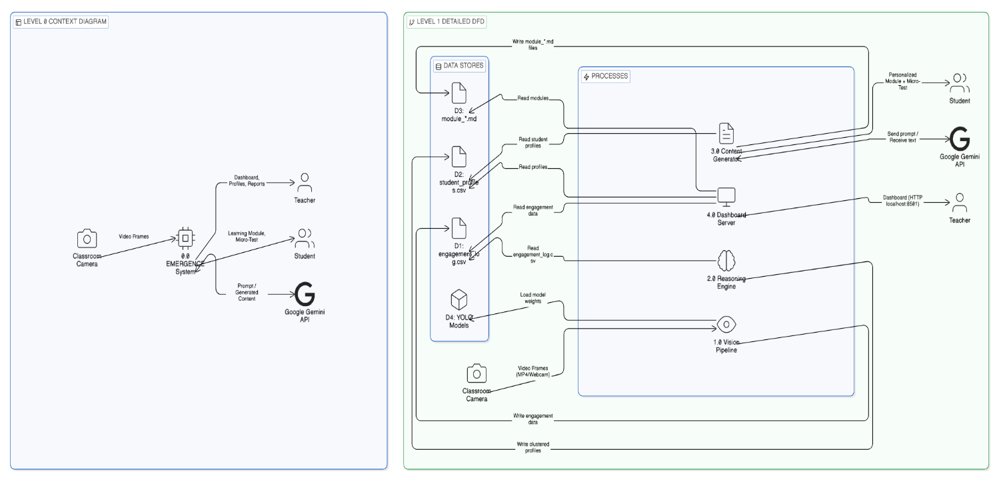

2.8 Assumptions and Dependencies
Assumptions:
- The classroom has a fixed camera with a clear view of all students (front-facing or overhead)
- Students are seated at mostly fixed positions during the session
- Lighting is adequate for YOLO detection (indoor classroom lighting sufficient)
- The input video/webcam resolution is at least 640×480 pixels
- Students are not wearing masks or face-covering that would obstruct keypoint detection
- The system has internet access for Gemini API calls (offline fallback not available for generation)
- A valid Gemini API key is configured in the
.env file
Dependencies:
- Ultralytics YOLO — Core dependency for detection and pose estimation
- Google Gemini API — Required for content/test generation (external service dependency)
- OpenCV — Required for video processing and optical flow
- Scikit-learn — Required for K-Means clustering
- Streamlit — Required for dashboard UI
- Python 3.10+ — Runtime dependency
- YOLO model files — yolo26m.pt and yolo11n-pose.pt (pre-trained weights)

3. SYSTEM REQUIREMENTS

3.1 User Interface
The system provides two user interfaces:

1. Command-Line Interface (CLI) —
main.py
- Accepts arguments: --source (video path or webcam index), --topic (subject), --skip-vision (bypass vision layer)
- Outputs progress to terminal with phase markers (Phase 1: Vision → Phase 2: Reasoning → Phase 3: Generation)
- Displays real-time OpenCV visualization with color-coded bounding boxes (green = engaged, red = disengaged)

2. Streamlit Web Dashboard —
app.py
- Header: Project branding with gradient banner
- Engagement Overview: Metric cards showing average engagement, total students, cluster counts
- Charts: Plotly-based interactive charts — engagement score distribution, per-student trends, cluster scatter plots
- Student Profiles Table: Shows each student's engagement metrics and cluster label with color-coded status badges
- Generated Content Viewer: Displays personalized learning modules generated per student
- Responsive Design: Custom CSS with Inter font, glassmorphism cards, animated badge

3.2 Software Interface
Module-to-Module Communication:
main.py
├── VisionPipeline (src/vision/pipeline.py)
│ ├── StudentDetector (src/vision/detector.py) → returns List[Dict]
│ ├── PoseExtractor (src/vision/pose.py) → returns Dict{gaze_score, posture_score}
│ └── MotionAnalyzer (src/vision/motion.py) → returns float
│ [OUTPUT] → engagement_log.csv
│
├── EngagementAnalytics (src/reasoning/analytics.py)
│ [INPUT] ← engagement_log.csv
│ [OUTPUT] → student_profiles.csv (DataFrame)
│
├── MicroTestGenerator (src/reasoning/assessment.py)
│ [INPUT] ← student profile (Dict)
│ [OUTPUT] → JSON {question, options, correct_answer, reasoning}
│
├── CurriculumGenerator (src/generation/curriculum.py)
│ [INPUT] ← student profile (Dict), topic (str)
│ [OUTPUT] → Markdown string
│
└── ContentRenderer (src/generation/renderer.py)
[INPUT] ← content (str), student_id (int), topic (str)
[OUTPUT] → module_*.md files
External API Interface:
- Google Gemini API via google-generativeai Python SDK
- Model: gemini-2.0-flash
- Protocol: HTTPS REST (SDK abstracts this)
- Authentication: API key in environment variable GEMINI_API_KEY
- Retry Logic: 3 retries with exponential backoff (30s, 60s, 90s) for 429 rate-limit errors

3.3 Database Interface
EMERGENCE uses file-based data storage (no traditional DBMS):
Storage | Format | Purpose
data/output/engagement_log.csv | CSV (Pandas) | Frame-level engagement data
data/profiles/student_profiles.csv | CSV (Pandas) | Clustered student profiles
data/output/module_*.md | Markdown files | Generated learning content
.env | Key-Value | API key storage
Rationale: The system processes data in batch (per-session), and the data volume per session is small (~200-1000 rows). CSV provides simplicity, portability, and direct compatibility with Pandas for analysis. No concurrent write access is needed.
Future Scope: SQLite or PostgreSQL for multi-session persistence and historical trend analysis.

3.4 Protocols
Protocol | Usage | Details
HTTPS | Gemini API communication | All API calls to generativelanguage.googleapis.com over TLS-encrypted HTTPS
HTTP | Streamlit dashboard serving | Local development server on localhost:8501
DirectShow / V4L2 | Camera capture | OS-level video capture protocol (DirectShow on Windows, V4L2 on Linux)
File I/O | Inter-module data transfer | CSV read/write via Pandas; Markdown file write for generated content
Security: API key stored in environment variable (.env file, excluded from version control via .gitignore). No student PII is stored — students are identified only by numeric track IDs.

Data Transfer Rates: YOLO inference ~5-30 FPS depending on hardware; Gemini API response ~1-3 seconds per call; CSV writes are batch (end of vision pipeline).

4. NON-FUNCTIONAL REQUIREMENTS
4.1 Performance Requirements
Metric | Requirement
Vision Processing | ≥5 FPS on CPU, ≥25 FPS on GPU (NVIDIA GTX 1060+)
Engagement Logging | 215+ rows for a 24-frame session, written at end of pipeline
Clustering | K-Means on 11 students × 2 features completes in <1 second
Content Generation | 1 module per student, ~2-5 seconds per Gemini API call
Dashboard Load | Dashboard renders within 3 seconds of data loading
Memory Usage | <2 GB RAM for vision pipeline; <500 MB for dashboard

4.2 Security Requirements
- API Key Protection — Gemini API key stored in .env file, excluded from Git via
.gitignore. Never hardcoded in source.
- No PII Storage — Students are identified by numeric YOLO tracking IDs only. No names, faces, or personal data are stored.
- Local Processing — Vision and reasoning layers run entirely offline/locally. Only generation layer requires internet (Gemini API).
- Data Access — CSV files stored locally on the server machine; dashboard accessible only on localhost by default.
- Video Privacy — Input video is processed frame-by-frame in memory; frames are not saved to disk (only aggregated numerical scores are persisted).

4.3 Software Quality Attributes
Attribute | Description
Adaptability | Modular 3-layer architecture allows each layer to be upgraded independently (e.g., swap YOLO version, change LLM provider)
Availability | Vision and Reasoning layers work fully offline; only Generation requires internet
Correctness | Engagement scores validated against expected ranges (0.0–1.0); K-Means clustering verified with actual classroom data
Flexibility | Configurable parameters in  config.py (model paths, thresholds); supports webcam or video file input
Maintainability | Clean separation into src/vision/, src/reasoning/, src/generation/ packages; centralized config
Portability | Pure Python, cross-platform (Windows, Linux, macOS); no OS-specific dependencies
Reliability | Retry logic for API failures (3 retries with backoff); graceful fallback for missing data
Reusability | Each module (detector, pose extractor, motion analyzer) can be used independently in other projects
Robustness | Handles edge cases: empty frames, missing keypoints, bounding box clamping, API quota exhaustion
Testability | Each component has standalone __main__ test blocks; CSV outputs enable manual verification
Usability | Simple CLI with 3 arguments; web dashboard with no setup beyond streamlit run app.py

5. OTHER REQUIREMENTS
- Ethical Compliance: The system should be deployed with informed consent of students. Video feeds should not be stored permanently. Only aggregated engagement metrics (numerical scores) are persisted.
- Scalability: Current MVP handles ~10-15 students per video. Future versions should support 30-60 students with optimized tracking.
- Extensibility: Architecture supports addition of new modalities (audio sentiment, heart rate via PPG) as new feature extractors plugged into the fusion formula.

APPENDIX A: GLOSSARY
Term | Definition
YOLO | You Only Look Once — real-time object detection model
YOLO-Pose | YOLO variant with keypoint detection for human pose estimation
Optical Flow | Computer vision technique to estimate motion between consecutive frames
K-Means | Unsupervised clustering algorithm that partitions data into K groups
Engagement Score | Weighted fusion of gaze, posture, and motion scores (0.0–1.0)
LLM | Large Language Model — AI model for text generation (Google Gemini)
Micro-Test | Short, auto-generated MCQ assessment adapted to student's engagement level
Gemini API | Google's generative AI API for text/content generation
Streamlit | Python framework for building interactive web dashboards
SCB Dataset | Student Classroom Behavior dataset with 8 labeled behavior classes
FPS | Frames Per Second — measure of video processing speed
PII | Personally Identifiable Information
MVP | Minimum Viable Product

APPENDIX B: ANALYSIS MODEL

- Use Case Diagram — Shows actors (Teacher, Student, System Admin) and their interactions
- Class Diagram — Shows all classes and their relationships
- Activity Diagram — Shows the full pipeline workflow
- Sequence Diagram — Shows object interactions for one pipeline run
- Data Flow Diagram (Level 0 + Level 1) — Shows data flow through the system
- State Diagram — Shows student engagement states and transitions

APPENDIX C: ISSUES LIST
# | Issue | Status | Priority
1 | Gemini API free-tier quota exhausted — all generated module files contain 429 errors | Open | High
2 | Using generic YOLO (person class only); custom SCB-trained model not yet integrated | Open | Medium
3 | Gaze estimation is approximate (ear-nose symmetry), not true eye tracking | Known limitation | Low
4 | Single-camera only, no multi-angle fusion | Future scope | Low
5 | No persistent database — session data stored in CSV files | Open | Medium

